Title of Project

**ABSTRACT**

**Objective:**

**Method:**

***Keywords:*** *.*

**I. INTRODUCTION**

Cancer is an abnormal cell development disorder that can expand or invade other areas of the body. Among the many types of cancer, skin cancer is a dangerous and deadly kind. Only if skin cancer is detected early enough is it treatable. Skin is critical in the human body since it covers all components, including muscles and bones. A lesion region refers to a diseased patch on the skin. Skin lesions come in various forms, and each lesion is classified according to its etiology or skin cells that generate it[1]⁠.

Lesions that are not melanocytic originate in other skin cells, for instance, squamous or basal cells. The difference between these lesions is made visually, using a collection of dermoscopic characteristics. Next to determine the kind of cancer, i.e., melanoma or benign. Additionally, choices are based on dermoscopic features. Skin lesions are the primary clinical manifestations of various disorders, including melanoma, basal cell carcinoma, and seborrheic keratosis[2]⁠. It may manifest itself on the chest, face, or back. It is formed in the legs of females. Melanoma is deadly cancer that rapidly spreads to other body areas and causes significant tissue damage.

Over twelve million individuals are diagnosed with cancer each year, and curing skin cancer remains the primary goal of the contemporary medical field. Computer-aided detection aids in the early identification of skin cancer. Doctors often discover it via the biopsy technique while diagnosing illnesses. As a result, this process is lengthy and unpleasant. On the skin, signs such as scarring, blue-white veiling, numerous gray-blue spots, multiple brown dots, globules, pigmented networks, and pseudopods may occur[3]⁠. Macroscopic pictures are often measurable since they are typically utilized for computational analysis and may be acquired with a standard digital camera or video camera[4]⁠.

Clinical images include several issues, including low resolution and items like hair, skin lines, shadows, and replications in the photographs. Due to these difficulties, studying skin lesions is very difficult. Table 1 [5]⁠ lists the major causes of melanoma as well as the risk factors. There are many stages involved in the computational approach for detecting skin cancer, including pre-processing, extraction and detection of features, and classification.

Table 1: Skin cancer cause and risk factors

|  |  |
| --- | --- |
| ***Cause*** | ***Risk Factors*** |
| Sunlight | 1. UV rays cause cancer.  2. Sunburn Blisters: Adults who have sunburns are more susceptible to malignancy.  3. Tanning. |
| Negative Effects of Medication | Antidepressants, antibiotics, and hormones all have adverse consequences. |
| Inherited | This illness is passed on via two or more generations of melanoma. |

This article discusses each step required in diagnosing skin cancer and the related techniques. Random Forest (RF), Support Vector Machines (SVM), XGBoost, LightGBM, AdaBoost, etc. Classifiers are used for classification.

Convolutional Neural Networks (CNN) is the most important image classification models in neural networks. The given picture is first transformed into a pixel array. The picture is then processed by several convolutional layers to ultimately produce a predicted output. For the training of the CNN models, large and well-illustrated datasets like ImageNet are utilized. The main benefit of transfer learning is to allow a task with a small data set to be trained using a pre-trained model with an extensive dataset[6]⁠. The proposed approach leverages the benefits of CNN models trained on large-scale datasets by transferring their knowledge to the classification phase, thus increasing detection accuracy without retraining the models. Additionally, the proposed approach eliminates the requirement for costly procedures often associated with machine learning methods, such as feature extraction and data augmentation, to balance the dermoscopic datasets under investigation.

The following list summarises the contributions of the proposed system:

* Transfer learning (EfficientNet and DenseNet) is used to obtain the feature from dermoscopic images and ensemble the features.
* Now pass the transferred learned (Concatenate) feature into supervised machine learning (such as SVM, RF, Bagging, XGBoost, LGBM, AdaBoost).
* Evaluate the performance of supervised machine learning.

The remaining article is structured as Section 2 Literature Review summarises the current knowledge about deep learning classification methods for Skin Cancer; Section 3 Proposed Methodology presents the fundamental ideas, a high-level overview of the dataset, and the suggested technique in depth; Section 4 Results and discussions illustrates the specifics of the training or training loop on the Kaggle platform, as well as the results of experiments; Section 5 provides context for the conclusion.

**II. RELATED WORKS**

Melanoma is a kind of skin cancer that causes malignant tumors on the skin. Dermatological images are used to detect skin cancer. Machine learning techniques based on high-performance photos are utilized to identify skin cancer with a high degree of accuracy—however, the model's accuracy by extracting more features while the model's sensitivity is raised. Numerous methods for skin cancer screening have been developed during the past several decades, particularly in recent years. Several of these methods use various pattern recognition algorithms to identify the illness[7]⁠.

One of the techniques for identifying the limit and quantification of lesions is the computer-aided diagnostic (CAD) system described by Schmid et al.[8]⁠. He has utilized a group of benign and malignant tumors recorded in the database together with histopathology and acted as a resource for reference data. This provides doctors with training during the diagnostic stage.

Celebi et al.[9]⁠ have suggested a pigmented lesion classification technique. Automatic border identification and form characteristics are also retrieved from the border to distinguish the lesion clearly. By transforming the Euclidean distance, the picture is divided into many significant areas to extract the texture and color associated information and put into an optimized pipeline for classifying the characteristics.

Thaajwer et al.[10]⁠ developed a technique for filtering and removing additional noise from the picture using image pre-processing. The skin lesion is subjected to segmentation, and characteristics are retrieved through several factors such as asymmetry in the lesion, border irregularities, lesion color, and lesion diameter utilizing the ABCD rule.

Kasmi et al.[11]⁠ automatically implemented ABCD lesion tracking to distinguish benign, malignant melanoma. The author isolated blue-white veils for variance structures, geometric properties, and pigment networks. In these works, the median filter removes artifacts, and with the aid of Gabor filters with various frequencies and orientations, the thick hairs are detected. Linear Interpolation hair mask restores the picture. GAC is utilized for the segmentation of lesions. Asymmetry in hue, shape, and brightness provides the foundation for A's core. The geometric features of the blue-white veil structures, networks, and lesions depend on the diameter (D) attribute.

Ant Colony Based Segmentation was utilized by Fekrache et al. to divide the dermoscopic picture. The retrieved characteristics include form, color, and texture. The classification methods used by the authors for classifying lesions include KNN and ANN[12]⁠.

Table 2 contains a summary of the literature review.

Table 2: Summary of Related Works

|  |  |  |  |  |  |
| --- | --- | --- | --- | --- | --- |
| ***References/Year*** | ***Dataset*** | ***Skin cancer diagnoses*** | ***Classifiers***  ***&***  ***Algorithms*** | ***Description*** | ***Results*** |
| [14]⁠, 2020 | ISIC | Melanoma/non-melanoma | ResNet50 | The suggested model outperformed InceptionV3, Densenet169, Inception ResNetV2, and Mobilenet in terms of performance. | Accuracy (93.5),  F1-score(85.5) |
| [15]⁠, 2020 | ISIC | Benign/ malignant | Mask-RCNN and VGG-16 | Mask-CNN was used to extract the area of interest, which was subsequently classified using ResNet152. | Accuracy (91.4),  Sensitivity (83),  Specificity(93) |
| [16]⁠, 2021 | ISIC | Melanoma/non-melanoma | VGG-16 and Ensemble ML | Classification using VGG-16-based feature extraction and an ensemble of RF, AdaBoost, and KNN. |  |
| [17]⁠, 2021 | HAM  10000 | 7 class | MobileNet-V2 and LSTM | Classification of skin diseases using a computerized method based on deep learning and Long Short Term Memory (LSTM) for GLCM-based features. | Accuracy (92.2), Sensitivity(93.4), Specificity (95.1) |
| [18]⁠, 2021 | Multi-  source | Melanoma/non-melanoma | DNN and Ensemble of SVM and RF | Thermograms extracted thermal characteristics from skin tumors and input features for two machine learning strategies: ensemble learning and deep learning. | Accuracy (95.8), F1-score (67.5) |
| [19]⁠,2020 | IEEE | Melanoma/non-melanoma | CNN with SMTP | The system employs a convolutional neural network (CNN) method with a loss function defined by the Similarity Measure for Text Processing (SMTP). | Accuracy (92), Sensitivity (96), Specificity (96.3) |
| [6]⁠, 2021 | ISIC (1000 sample image) | Melanoma/non-melanoma | GLCM and Machine Learning Algorithms | The features are extracted using GLCM, Movement Invariants, and GLRLM, and the classification is performed using SVM, RF, and ANN. | Accuracy (96.3) |
| [20]⁠2020 | ISIC | seven classes | Ensemble of CNN and Metadata | Ensemble two CNN models with metadata for multiclass classification. | Accuracy (93), F1-score (86.3) |
| [13]⁠2020 | HAM  10000 | Multiclass | Transfer Learning and SVM | Feature extraction using ABCDE rule and Fused with Deep learning features and apply SVM for classification | Accuracy (92.4), F-score (89.16), MCC (0.7953) |

CNN: Convolutional Neural Network, SVM: Support Vector Machine, RF: Random Forest, ANN: Artificial Neural Networks

**III. PROPOSED METHOD**

Figure 1 shows a proposed framework for the diagnosis and categorization of skin cancer. It comprises four phases:

1. Pre-processing of dermoscopic images
2. Feature extraction using transfer learning
3. Classification (Using Supervised Machine Learning)
4. Performance and Comparison of ML algorithms

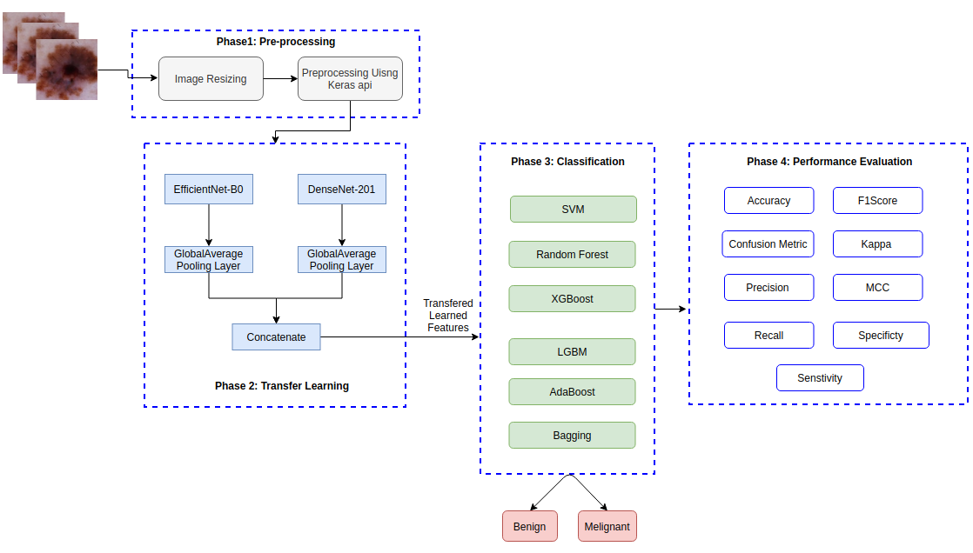

Figure 1: Proposed Skin Classification Framework

The dermoscopic images are resized from 1024x1024 dimensions to a size of 224x224. After that, apply the Keras-based pre-processing function to preprocess the resized images. Furthermore, pre-processed images pass into the CNN architecture for feature extraction. In this study, the author uses the EfficientNet-B0 and DenseNet-201 transfer learning models for extracting the features. Usually, DenseNet-201 and EfficentNet-B0 generate the 1024 and 1264 features, respectively. To further narrow the features, use the AveragePooling layer to narrow the features (four features each). Now, concatenate the transferred learned features. We use supervised machine learning algorithms (such as SVM, LGBM, Random Forest (RF), XGBoost, etc.) on transferred learned features and compared machine learning performance algorithms based on several assessment criteria.

1. **Dataset**

The SIIM-ISIC-2020[21]⁠ dataset with 33,126 training pictures is utilized in this study. It contains 33,126 dermatoscopic pictures of pigmented lesions representing seven distinct types of skin cancer; however, the dataset is divided into two categories, melanoma and benign. A training set of images depicting the many types of cancer has been published and made publicly accessible through the ISIC repository. The dataset's colored pictures were originally 1024 X 1024 in size. Figure2 shows the images of benign and malignant diseases.

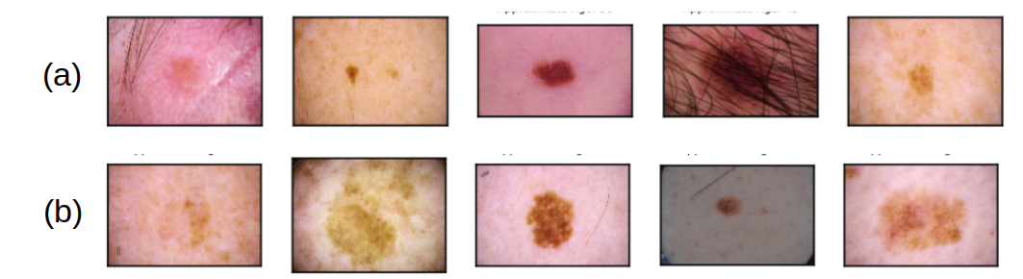

Figure 2: (a) Benign images and (b) Malignant images

1. **Pre-processing**

The preprocessing step improves the quality of the picture used for detection. We resize the images to CNN models and then apply Kears[22]⁠ default API for pre-processing.

Figure 3 shows images of after preprocessing steps.

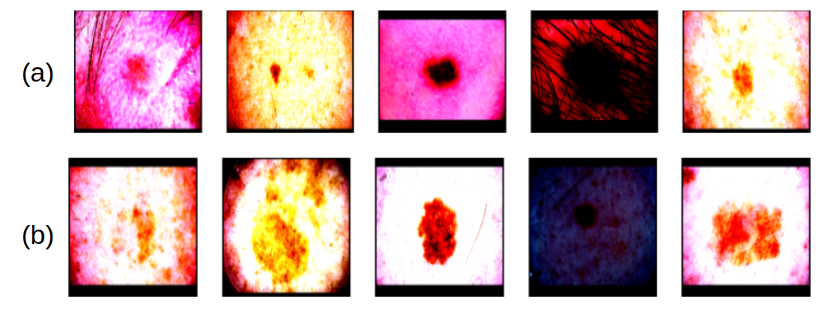

Figure 3: after the image resize and pre-processing steps; (a) Benign images (b) Malignant

1. **Feature Extraction Using Transfer Learning**

Transfer learning refers to the concept of surpassing the solitary learning paradigm and applying information gained for one task to another. We proposed a transfer learning methodology for feature extraction from dermoscopic images to extract characteristics from skin pictures. Therefore, the advantage of TL may be great if the target database is much smaller than the original; this prevents overfitting, particularly for imbalanced datasets.

We applied these eight pre-trained CNN models on the ImageNet database to detect generic items in this study to acquire and extract the significant characteristics of the skin pictures. As a result, these models can be rapidly retrained and evaluated using skin pictures to remove key attributes from the input skin images; this is a significant advantage of the TL approach.

**3.3.1. DenseNet**

DenseNet[23]⁠ combines all of the layers to create an efficient deep model. It is very similar to ResNet, with a few key distinctions. DenseNet is a model built in the same way as ResNet, but each layer is feed-forward to the next layer. Through these feed-forward connections, the number of layers is increased from L to L(L + 1)/2 [24]⁠. Each layer's entry contains the feature maps for all preceding levels. DenseNet has a lot of advantages, including the ability to solve the vanishing gradient issue. DenseNet, trained on imagenet, incurs higher computational costs yet achieves substantial gains [25], [26]⁠. Figure 4 depicts the DenseNet-201 architecture.

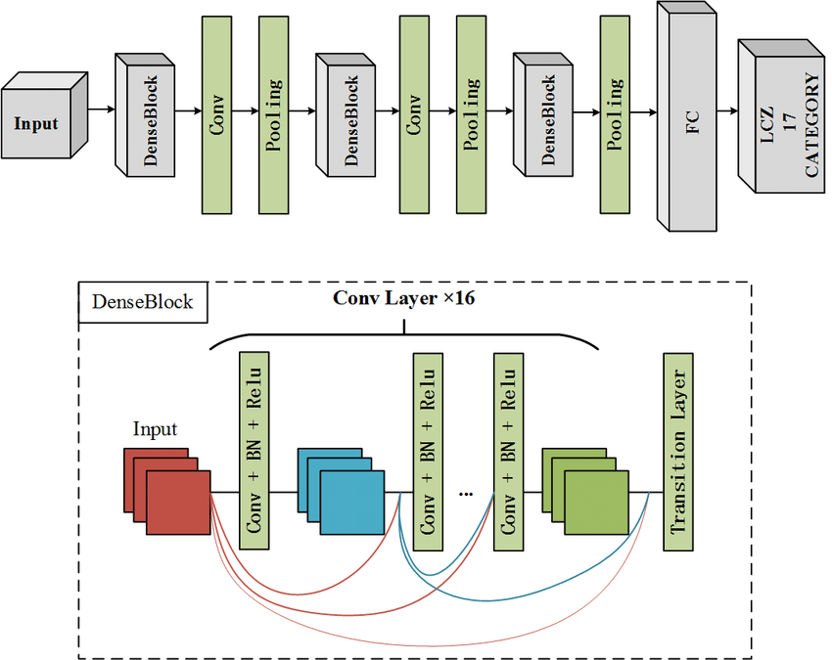

Figure 4: DenseNet-201 Architecture

**3.3.2. EfficientNet**

Google unveils a model family, 'EfficientNet: Rethinking Model Scaling for Convolutional Neural Networks' in Google's 2019 ICML paper. Their work offers a fundamental technique for improving CNN model scalability and performance. CNN requires dimensional scaling — depth, breadth, or resolution – to function better. In practice, the dimensions are changed randomly to improve model accuracy. Their study provides a more systematic way to describe scaling by evenly scaling each size with specified scaling coefficients. They developed a new base network that improves efficiency and accuracy since its success depends on scalability and the primary network (FLOPS). The resulting design uses a larger mobile inverted bottleneck convolution (MBConv). Figure 2 shows the EfficientNet-B0 architecture used in this study. However, we are interested in how well the architecture described in the ICML paper transfers to skin injury classification[27]⁠. EfficientNet-B0 shows in figure 5.

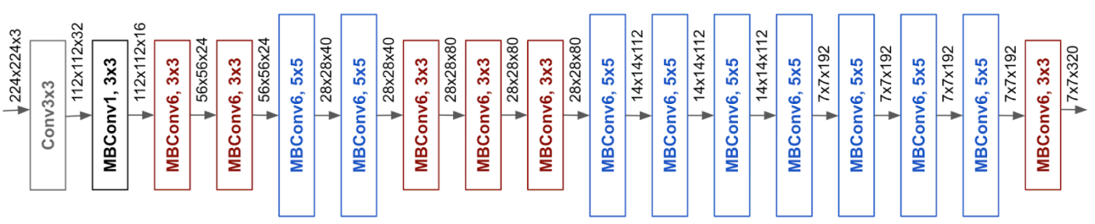

Figure 5: EfficientNet-B0 Architecture

1. **Supervised Machine Learning**

This study utilized supervised machine learning methods. The labeled training data set is utilized in supervised machine learning algorithms for fundamental algorithm practice. This validated model is then placed into a non-labeled data set for testing and categorizing[28]⁠. The accompanying part provides a summary of these supervised machine learning algorithms for illness diagnosis.

**3.4.1. Support Vector Machine (SVM)**

SVM is a learning machine method based on Compared to other machine learning algorithms; in literature, SVM performs better or more equally. SVM solves a restricted quadratic to distinguish between two classes and may also resolve the multi-class issue. Building the limits in the dataset ideally does not appear to be modifying the SVM algorithm. SVM method optimizes the margin between hyperplanes and data points[29]⁠.

When data are provided in where is input vector and is the result that shows which belongs to. SVM attempts to identify a maximum hyperplane margin that splits the whole line into various classes. The distance from each class between the hyperplane and the closest point is maximized.

The hyperplane equation is stated as:

|  |  |  |  |
| --- | --- | --- | --- |
|  |  |  | *(1)* |

where is the input vector, is a normal vector to the hyperplane, and is the intercept term.

SVM’s goal is to minimize:

|  |  |  |  |
| --- | --- | --- | --- |
|  |  |  | *(2)* |

where represent the Hinge Loss, and is the regularization term.

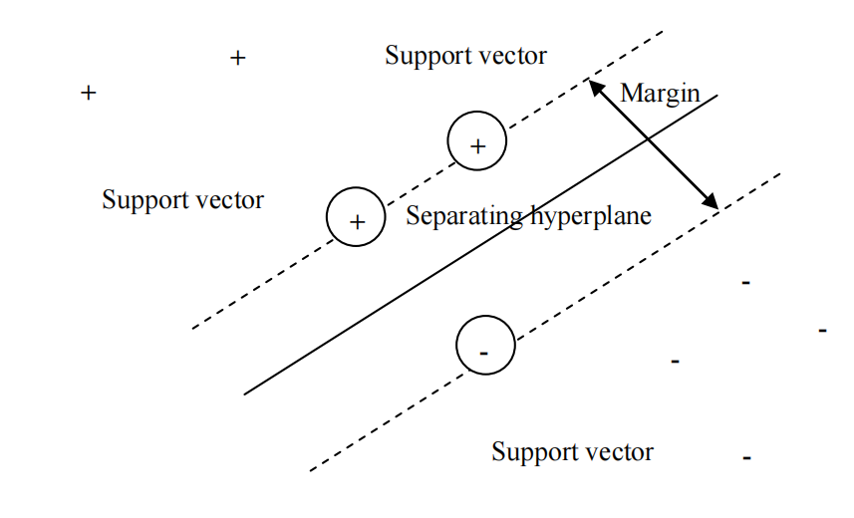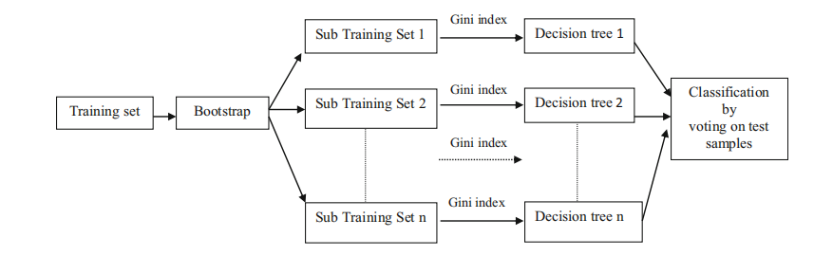

Figure 6: SVM Classifiers Figure 7: Random Forest Classifiers

**3.4.2. Random Forest (RF)**

It is a supervised classification method. This method results in the formation of a forest. When a forest has more trees, the forest becomes so dense that this categorization gives accurate results. Random Forest utilizes the Gini Index (GI) during tree construction to choose the optimal collection of attributes[29]⁠.

|  |  |  |  |
| --- | --- | --- | --- |
|  |  |  | *(3)* |

where is the probability of an element being classified into a class.

The Random Forest flowchart is shown in figure 7.

**3.4.3. AdaBoost**

AdaBoost is a commonly used ensemble learning-based supervised machine learning classifier. Combining several weak classifiers into a robust classifier uses an adaptive enhancement method and improves classification results. At the start, all observations are given the same weight. The weights of the observations vary according to the coefficients of weak classifiers, and the coefficients of the applicable classifiers are calculated using the estimation error value. Thus, the value of the mistake produced by a classifier is referred to as the classifier's coefficient[29]⁠. As a result, the AdaBoost algorithm may increase the weight of misclassified data while decreasing the weight of properly recognized observations. It will place a greater emphasis on wrongly categorized data in future versions. Finally, all generated weak classifiers are merged using a linear combination technique to build a more robust classifier with correct classification performance.

**3.4.4. Bagging**

As an ensemble meta-estimator, a Bagging classifier fits base classifiers to random subsets of the original dataset, then aggregates their predictions (either by averaging or voting). Incorporating randomization into the building process of estimators may decrease its variation. To train each base classifier, N instances (or data) from the original training dataset are chosen at random, with replacement. Each base classifier has its own training set. Many of the original facts may be duplicated, while others may be omitted. Averaging or voting decreases overfitting (variance) but increases bias, offset by reducing conflict [30]⁠.

**3.4.5. Extreme Gradient Boosting Machine (XGBoost)**

Extreme Gradient Boosting (XGBoost) is used for supervised learning tasks, such as classifying melanoma and non-melanoma. XGBoost's outstanding scalability and fast execution speed have contributed to its popularity as a machine learning technique. Each iteration of this research included the usage of a tree booster[31]⁠. The L2 regularisation term was employed to keep the model basic and avoid overfitting, and the maximum depth was restricted. Figure 8 shows the levelwise tree growth of XGBoost Classifier.

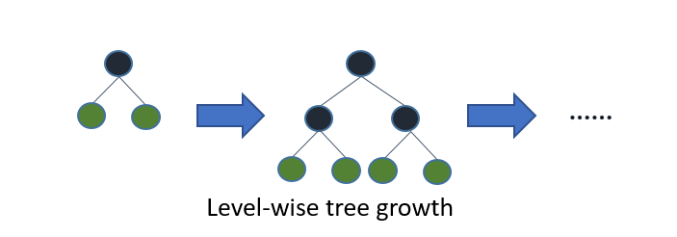

Figure 8: XGBoost Classifiers

**3.4.6. Light Gradient Boosting Machine (LGBM)**

LGBM is a framework for gradient boosting that makes use of a tree-based learning method. LGBM develops trees vertically, while the other algorithms grow trees horizontally, which means that LGBM grows trees leaf-by-leaf, while the other algorithms grow trees level-by-level. It will grow the leaf with the greatest delta loss. The leaf-wise method may significantly decrease loss when expanding the same leaf than the level-wise algorithm[31]⁠. Figure 9 shows the leaf-wise tree growth of the LGBM classifier.

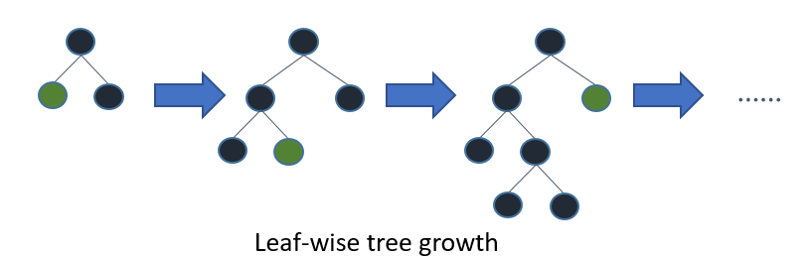

Figure 9: LGBM Classifiers

**IV. DISCUSSION**

**V. Pert Chart**

**References: (IEEE)**

[1] A. G. C. Pacheco and R. A. Krohling, “The impact of patient clinical information on automated skin cancer detection,” *Comput. Biol. Med.*, vol. 116, p. 103545, 2020, doi: https://doi.org/10.1016/j.compbiomed.2019.103545.